Deck 1: Total Cards: 30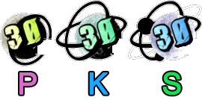

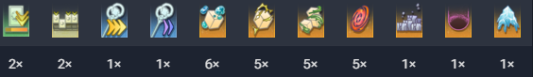

Deck 2: Total Cards: 30



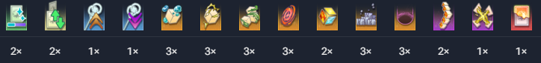

Deck 3: Total Cards: 30